KSS Optima

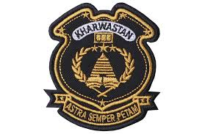

Prepared by
Mr. Kyle Pillay

